**Raspberry Pi Installation:**

**Step1**

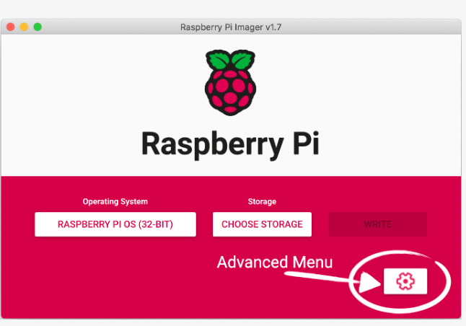

**Step 2:**

**Step 3:**

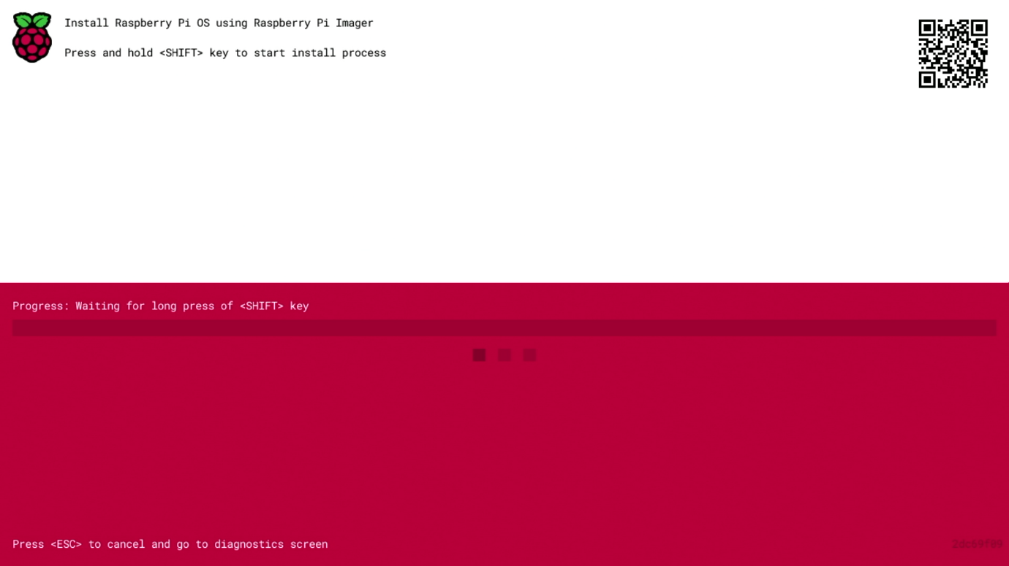

**Step 4:**

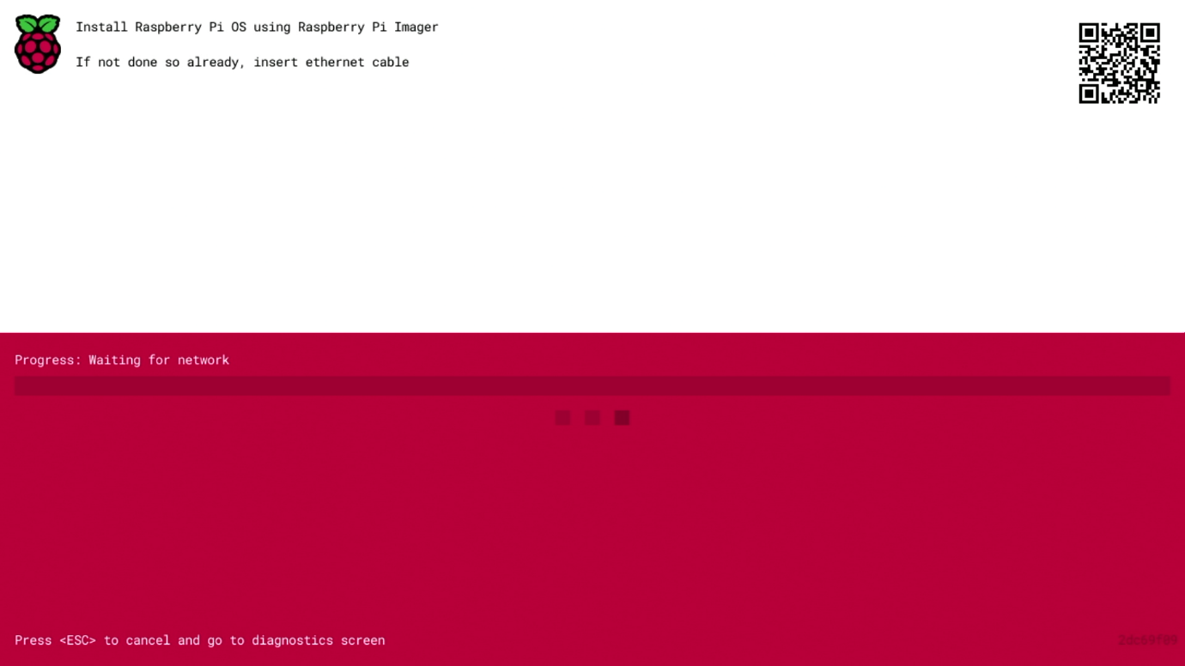

**Step 5:**

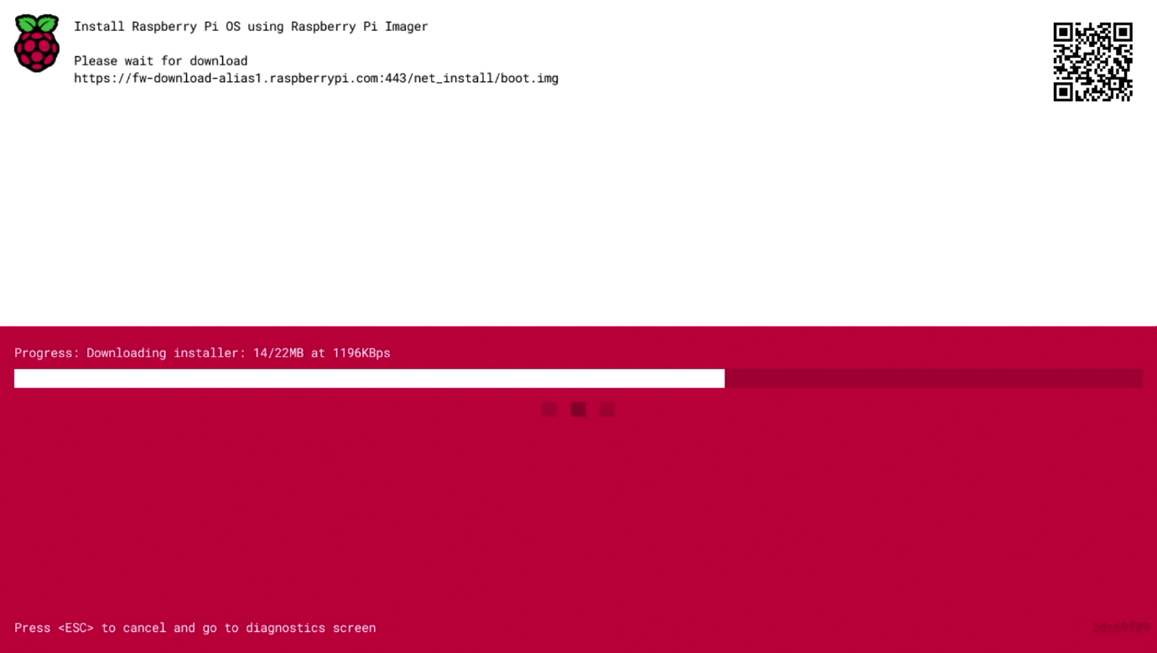

**Step 6:**

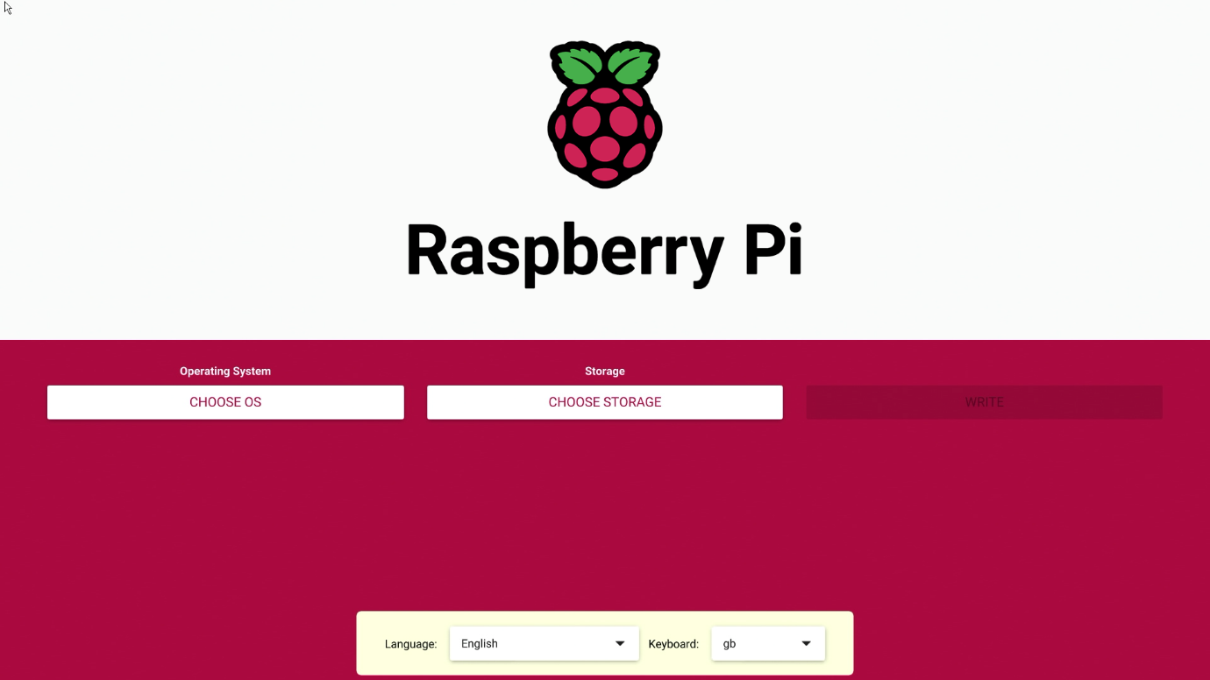

**Configuration on the first boot:**

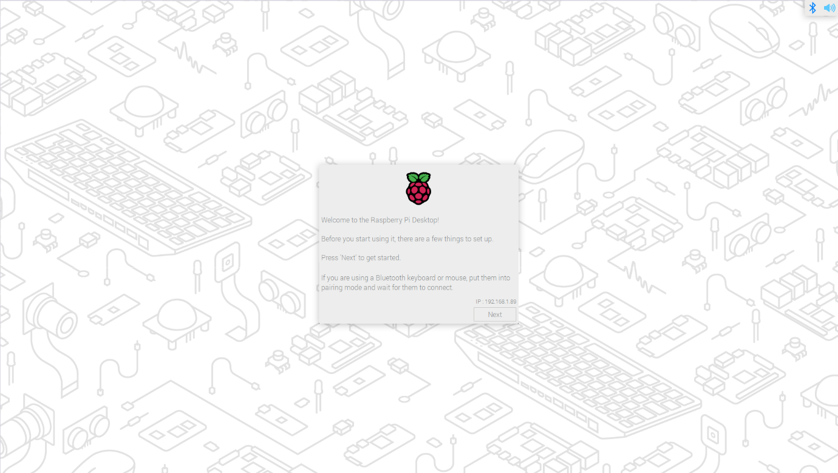

**Create User Account:**

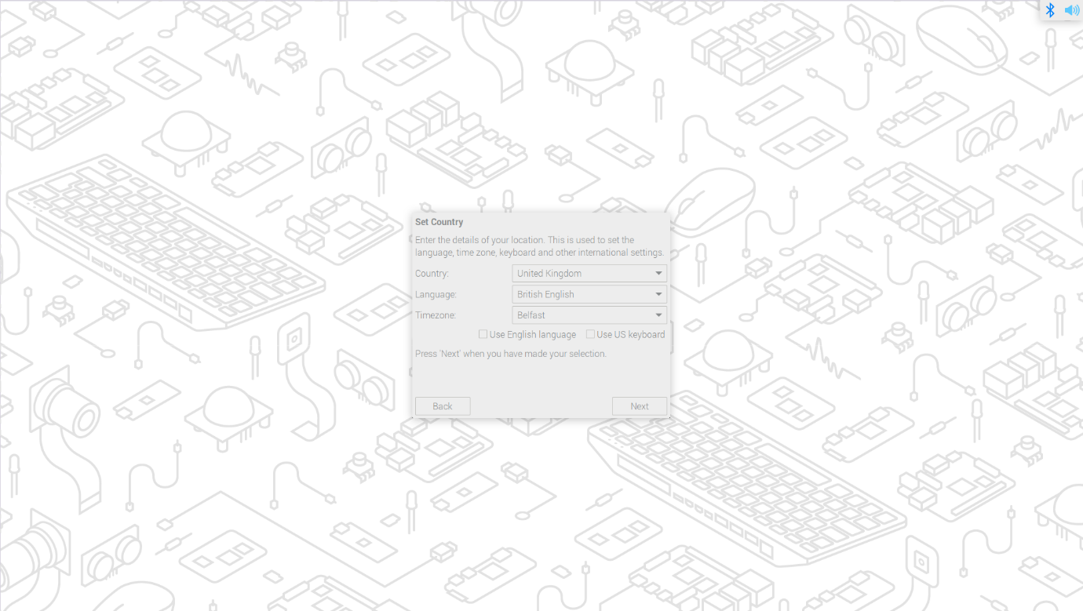

**Configuration:**

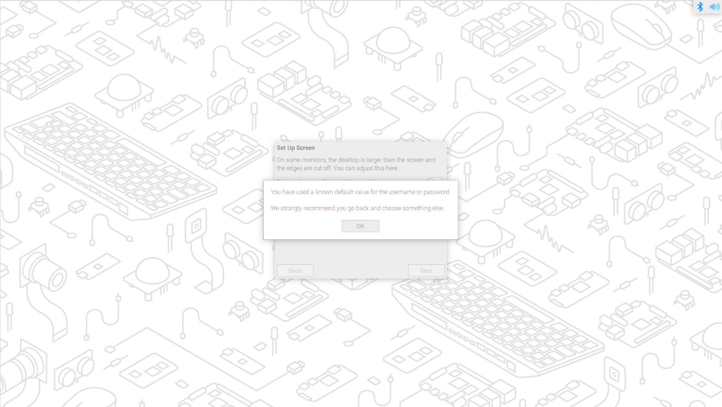

**Once the operating system is updated you will be prompted to reboot your Raspberry Pi.**

